Testing ISR:

1. Screening for ALL positions:

* I tried to screen one candidate for all positions, he was unprocessed and had only one priority, error message showed up.

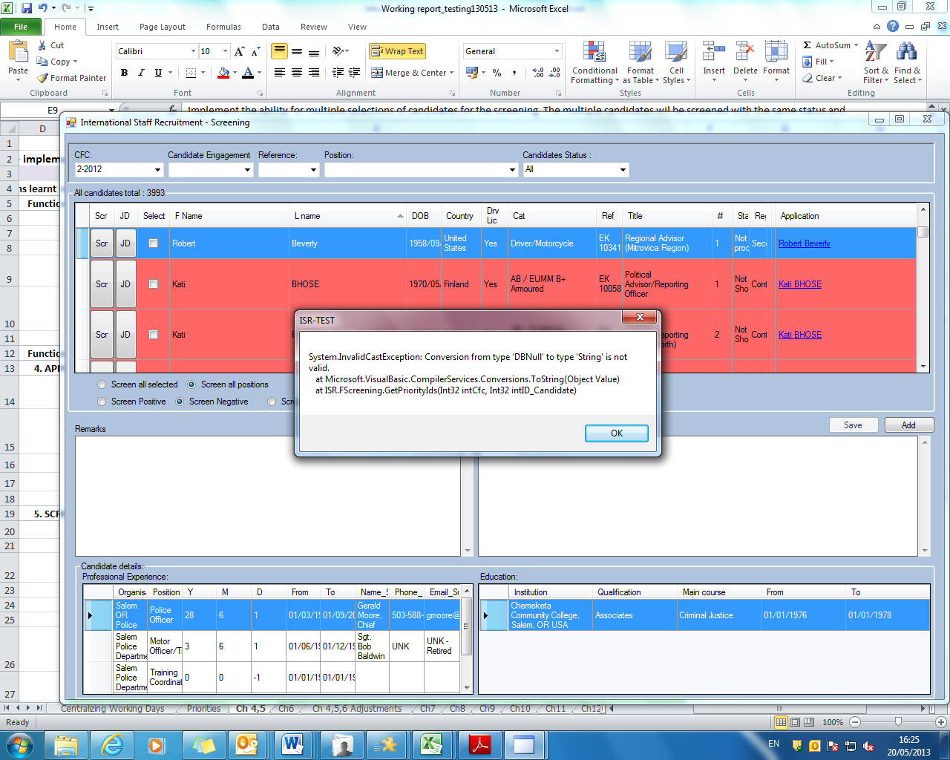

* When I tried to screen positively other candidate for all positions (he was unprocessed for one and negative for two), unprocessed didn’t change, but negative screenings were changed to positive. Andrei: Fixed;
* TODO: Screening: only candidates with ID_Status in (1, 24, 25, 26); Removed (2, 3, 4, 5, 6, 7, 8, 9, 10, 11, 12, 13, 14, 15, 16, 17, 18, 19, 20, 21, 22, 23,) –Q to be included in the email on what “ALL” should include.

TODO: Preserve the location of the cursor within the dgw_Candidates/All and for filters

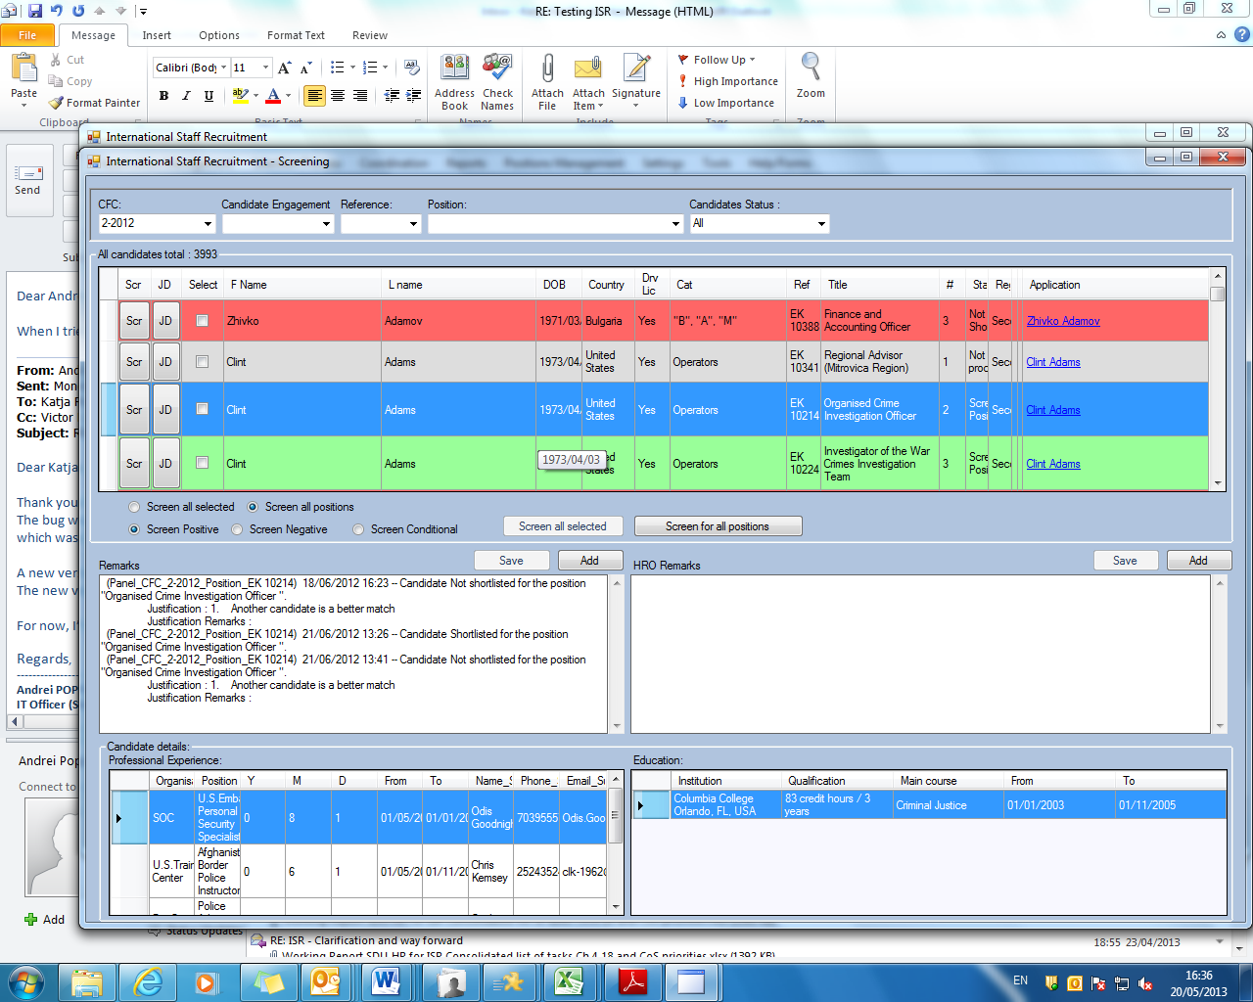

1. Screening ALL selected candidates for one position, when I screened 4 candidates negatively for one position, the function was working. After that decision was not allowed to change as group. When I entered one candidate and change selection to positive, all candidates that were colored with color matching screening status were discolored.

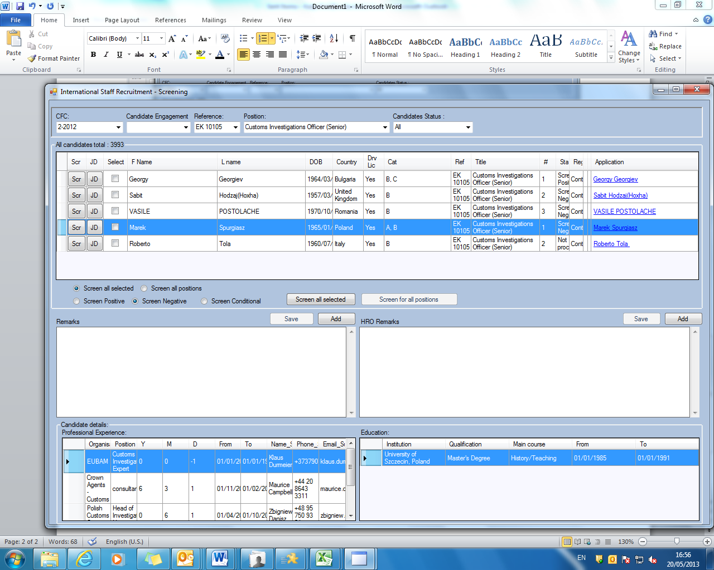

SHORTLISTING

1. Candidates for the position were screened

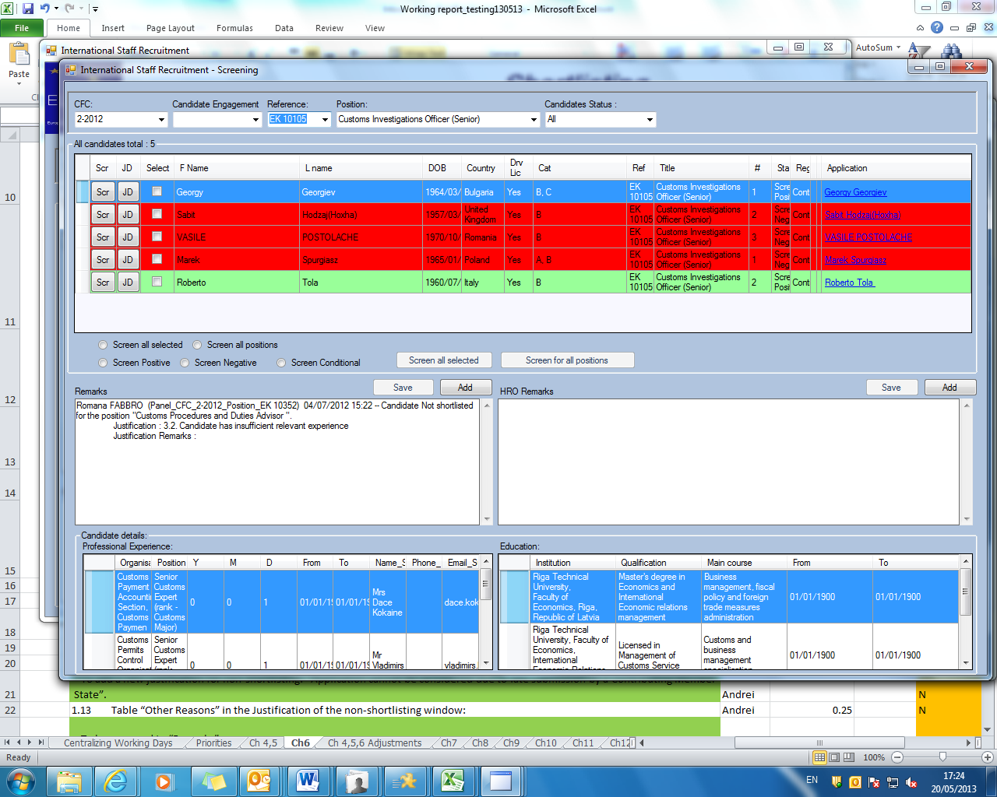

When I go to Shortlist window, I can’t see anything.

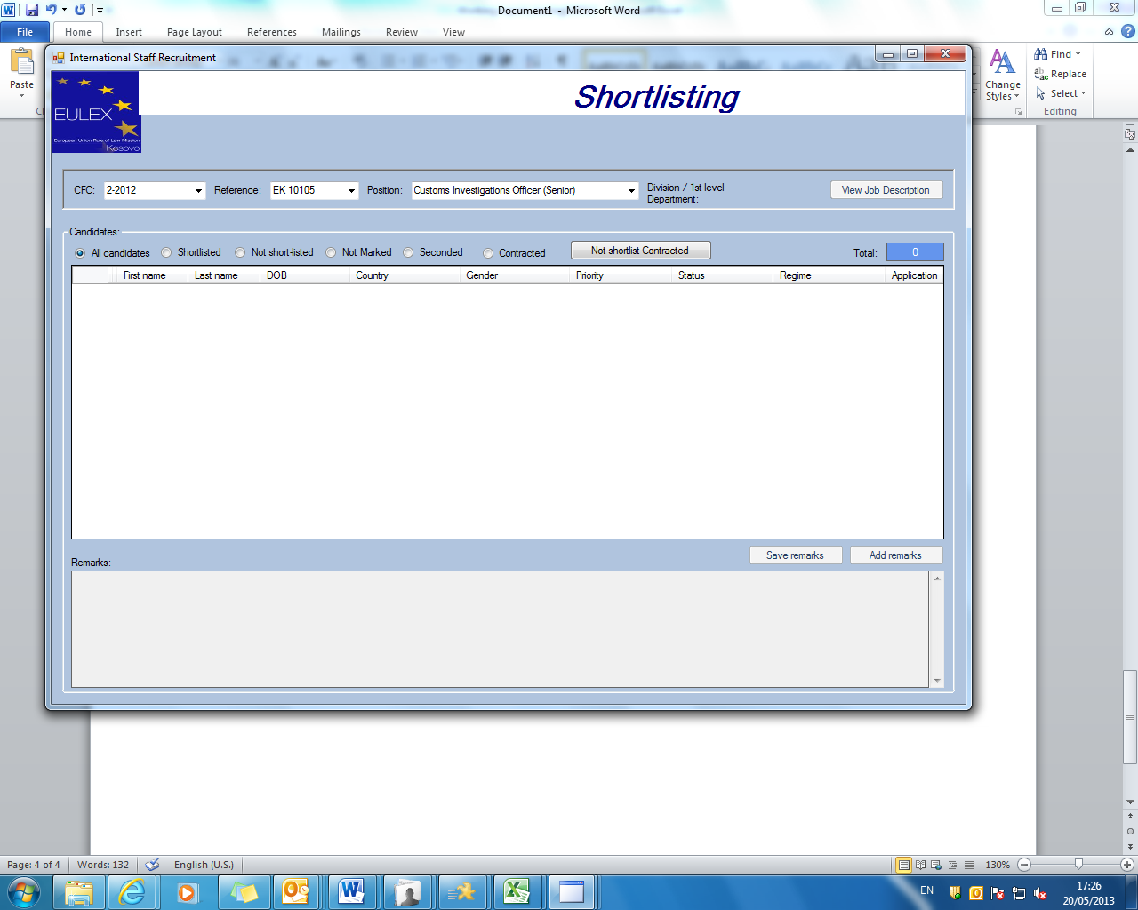

1. IMPORTING APLICATIONS:

-when we tried to import aplications it showed this error

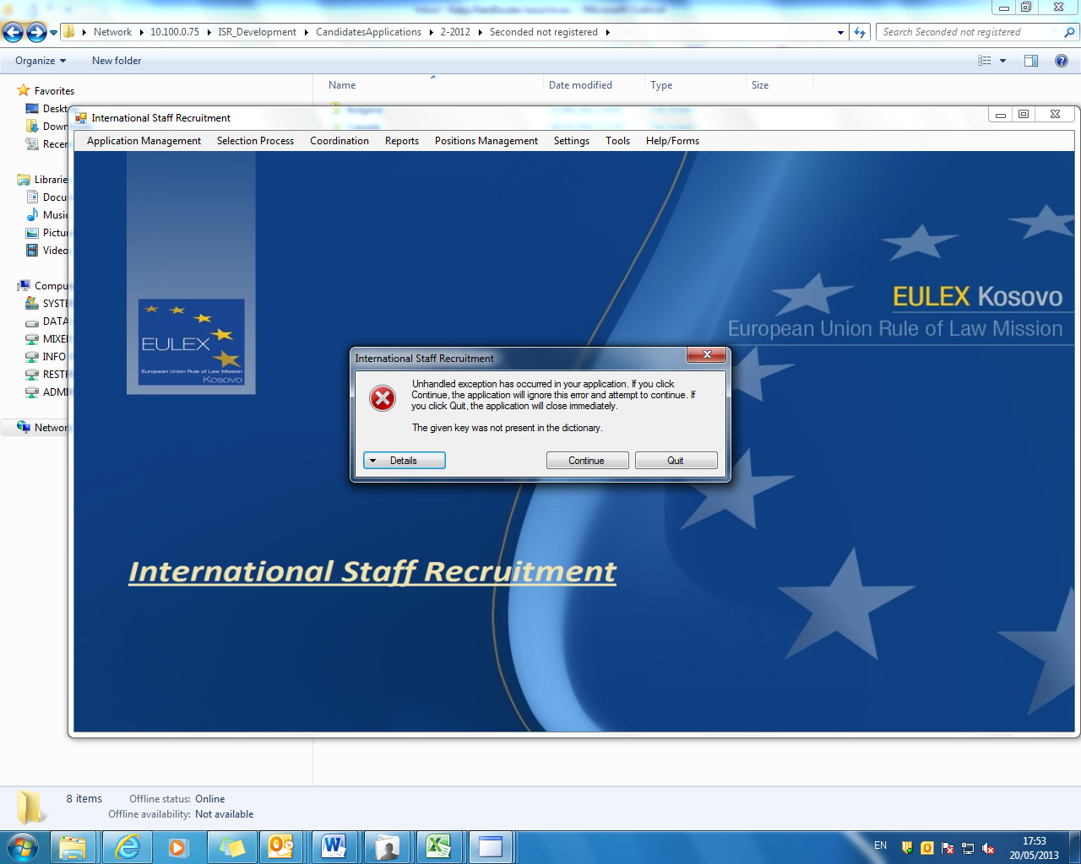

When I tried to enter applications again the application reported them as registered, but the applications stayed in not registered folder.